**C64 PSU Global Rev. 1**

**Module Description**

# Introduction

The C64 PSU Global is a replacement power supply for the Commodore C64, which is suitable to power the Commodore computer from 115V and 230V.

There are two options for transformers for the 9VAC, one is capable of being switch between 115V and 230V.

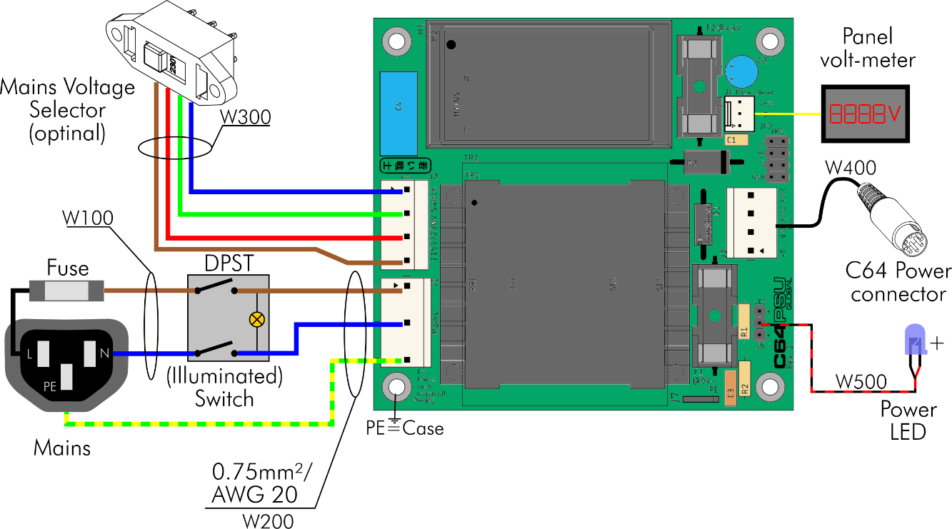

Figure 1: Block diagram

The 5VDC are generated by an AC/DC converter. There are two options that can be placed on the PCB, both have a wide range input (85VAC-264VAC) and are suitable for both main voltages without switching. The technical data of the power supply vary, depending on the chosen options:

|  |  |  |  |
| --- | --- | --- | --- |
| **Option** | **Type** | **Mains** | **Output** |
| Transformer TR1 | Hahn BV UI 304 0153 | 115VAC/230VAC | 9VAC/1.1A |
| Transformer TR2 | BREVE TUFVASSONS TEZ10/D230/9V | 230VAC | 9VAC/1.1A |
| AC/DC M1 | RECOM RAC10-05SK/277 | 85VAC-305VAC | 5VDC/2A |
| AC/DC M2 | Mean Well MPM-10-5 | 80VAC-264VAC | 5VDC/2A |

The mains voltage selector switch is only required for the option Transformer TR1. A fuse for the mains is external and mandatory. It is recommended to use a combination of mains with an integrated fuse and maybe a switch. The switch should switch off both, the life and the neutral mains. In Figure 1, an illuminated mains switch is shown. Its lamp is located at the switched side. A not illuminated switch is recommended for the 115V/230V version, since the light of a 230V switch is pretty dim at 115V.

A power LED can be connected. At least one signal should allow the use to notice, whether the PSU is switched on or off, the Power LED or the illuminated mains switch.

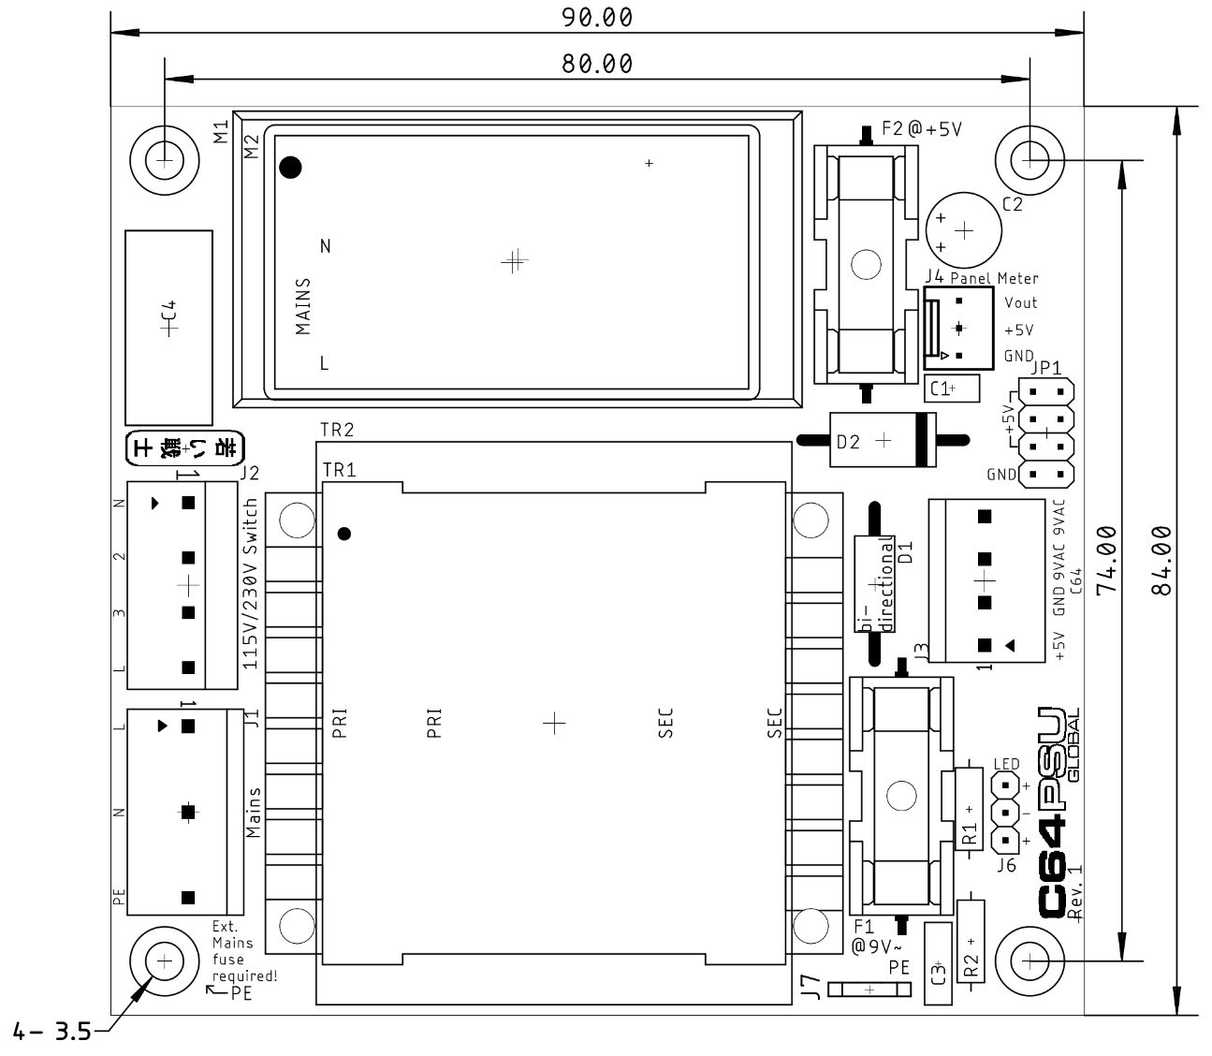

Figure 2: Dimensions

A panel meter can be connected. The common panel meter measures the current in the negative (ground) lead. The panel meters might be very inaccurate and the current and voltage should be adjusted with a load resistor and a multimeter. Sometimes, it is not even possible to adjust the current properly, so the panel meter is not really recommended. In case the panel meter is not installed, JP2 has to be bridged with jumpers.

A not yet developed over voltage protector (aka C64 saver) can be connected to JP1. In case this is not installed, JP1 has to be bridged with jumpers.

An R/C combination (R2/C3) between GND and PE serves for creating System Ground, which is tied to protective earth (PE). Some further power supplies for the monitor or the S-Video/HDMI converters might inject (a weak) mains voltage into the system. This happens due to a capacitive coupling to mains within those PSUs and could be felt when touching the C64 ports.

# Connectors

## J1 – Mains connectors

* Molex KK 396 Header, Vertical, Friction Lock, 5 Circuits, Tin (Sn) Plating (Pin 2 and pin 4 removed): P/N 0026604050
* KK 3.96mm Crimp Terminal Housing, Friction Ramp, 5 Circuits, Natural: P/N 09503051
* KK 396 Crimp Terminal 2478, 18-24 AWG, Bag, Brass Tin (Sn): P/N 08500106.

|  |  |
| --- | --- |
| Pin | Signal |
| 1 | L (hot) |
| 3 | N (neutral) |
| 5 | PE (protective earth) |

## J2 – Mains Voltage Selector

This is an option and only required, if the TR1 (the 115V/230V type) is used.

* Molex 5.08mm Pitch SPOX Wire-to-Board Header, Vertical, with Friction Lock, 4 Circuits, P/N 10321041
* Molex 5.08mm Pitch SPOX Crimp Terminal Housing, 4 Circuits, P/N 10013046
* Molex SPOX Crimp Terminal, 18-24 AWG, Brass, P/N 08701031

As a switch, the type Bulgin T22205B436B is suggested.

## J3 – C64 Power Connector

* Molex KK 396 Header, Vertical, Friction Lock, 4 Circuits, Tin (Sn) Plating:   
  P/N 0026604040
* KK 3.96mm Crimp Terminal Housing, Friction Ramp, 4 Circuits, Natural: P/N 09503041
* KK 396 Crimp Terminal 2478, 18-24 AWG, Bag, Brass Tin (Sn): P/N 08500106.

|  |  |
| --- | --- |
| Pin | Signal |
| 1 | +5V |
| 2 | GND |
| 3 | 9VAC2 |
| 4 | 9VAC1 |

## J4 – Panel Volt-Meter

* Molex KK 254 Wire-to-Board Header, Vertical, with Friction Lock, 3 Circuits, Tin (Sn) Plating: P/N 22272031
* KK 254 Crimp Housing, 3 Circuits, Natural: P/N 22-01-3037
* KK 254 Crimp Terminal, 22-30 AWG, Bag, Hot Tin (Sn) Dip Plating: P/N 08500114

|  |  |
| --- | --- |
| Pin | Signal |
| 1 | GND |
| 2 | +5V (supply) |
| 3 | +5V (measurement) |

## 

## Power LED – J6

* Pin header, 1x3 circuits, 2.54mm (0.1”) pitch
* Crimp housing: Dupont crimp housing
* Dupont crimp terminals

It is possible to use a widely available (Ebay, AliExpress etc.) Dupont cable, which can be cut and soldered to the LED.

|  |  |
| --- | --- |
| Pin | Signal |
| 1 | LED + |
| 2 | LED - |
| 3 | LED + |

## J7 – PE Connection

The PE connection to the chassis is accomplished via the mounting hole marked with “← PE”. This is directly connected to the mains connector J1, Pin 5. In case other metal parts have to be grounded, a 6.3 x 0.8 FastOn (spade) connector can be installed in J7.

# Jumpers

## JP1 – Over-Voltage Protection

In case an over-voltage protection is not installed, the pin header JP1 should be bridged (3x Input 5V ↔Output 5V). The jumpers should be rated 1A or more.

|  |  |  |  |
| --- | --- | --- | --- |
| Signal | Pin | Pin | Signal |
| Input 5V | 1 | 2 | Output 5V |
| Input 5V | 3 | 4 | Output 5V |
| Input 5V | 5 | 6 | Output 5V |
| GND | 7 | 8 | GND |

# Wiring

## Introduction

**This device is connected to mains. Mains voltage is potentially lethal. High currents, that can occur in this device can cause fire hazards. Do not carry out this work, if you are not trained!**

Up to four sorts of crimp contacts are required for installing this device:

* Molex SPOX/KK 3.96 (J1, J3, J5)
* Molex SPOX/5.08 (J2, option 230V/115V)
* Dupont 2.54mm

A crimp tool for the other types of connector is the Engineer PA-20. A cheaper, but less good tool is the IWISS IWS-2820M. It is also possible to crimp the terminals with the SN-28B tool. Please refer to the Cable Making Guide on my website: <http://tech.guitarsite.de/cable_making.html>

The mains should be wired with 0.5mm²/AWG21 to 0.75mm²/AWG20 cables. It might be a good idea to salvage a piece (30cm) of mains cable, this will provide the proper cable colors for wiring up the mains connector, switch and mains voltage selector switch.

The colors for the mains cables are different, depending on the country. They can be found here:

<https://en.wikipedia.org/wiki/Electrical_wiring>

|  |  |  |
| --- | --- | --- |
| Mains Connection | EU/UK/Australia | North America |
| Live/hot | brown | black |
| Neutral | blue | white |
| Protective Earth (PE) | yellow/green | green or yellow/green |

The cable colors should be according to the regulations of the respective country.

The lengths are calculated for the 3D printed case, which is provided with this project. It can vary, if a different case is used.

## The Mains Cable (W100)

This cable connects the appliance inlet with the mains switch (**L**ive and **N**eutral). It is referenced with “W100”.

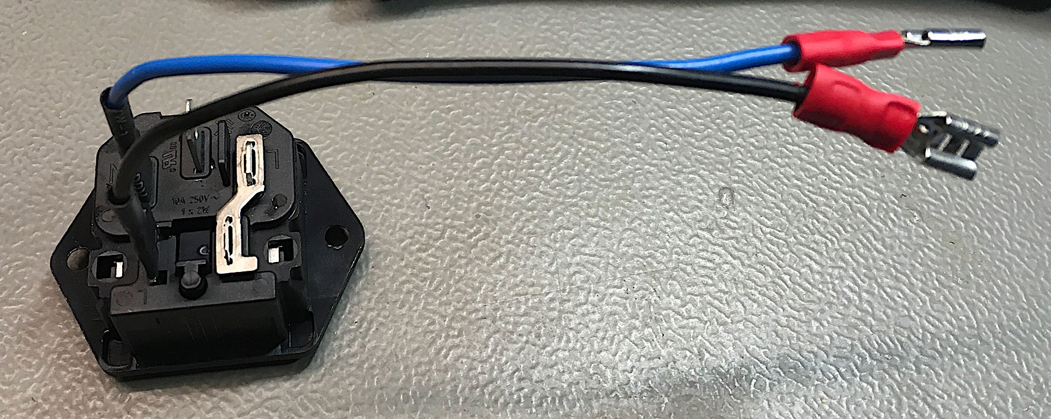

Figure 3: Mains cable (inlet) – W100

|  |  |  |  |  |
| --- | --- | --- | --- | --- |
| Signal | Color | Length | Connects to | Terminal |
| Live/hot | Brown* | 11cm | Switch/input (live) | FastOn 4.8x0.8 |
| Neutral | Blue* | 11cm | Switch/input (neutral) | FastOn 4.8x0.8 |

* Colors according to the local regulations (see above)

Appliance inlet: Schurter 6200.2300

The cables are directly soldered to the spade connectors and covered with a short piece of shrinkable sleeve (Figure 3).

## The PCB Mains Cable (W200)

This cable connects the PCB (J1) to the mains switch and the PE of the mains connector. It is referenced by “W200”.

|  |  |  |  |  |
| --- | --- | --- | --- | --- |
| Signal | Color | Length | Connects to | Terminal |
| Live/hot | Brown* | 11cm | Switch/output (life) | FastOn 4.8x0.8 |
| Neutral | Blue* | 11cm | Switch/output (neutral) | FastOn 4.8x0.8 |
| Protective Earth | Yellow/green* | 8cm | Mains connector (PE) | FastOn 6.3x0.8 |

* Colors according to the local regulations (see above)

Crimp housing: Molex 09503051

Crimp terminals (3 ea): Molex 08500106

Faston 6.3x0.8 for PE

Faston 4.8x0.8 (2 ea) for L and N

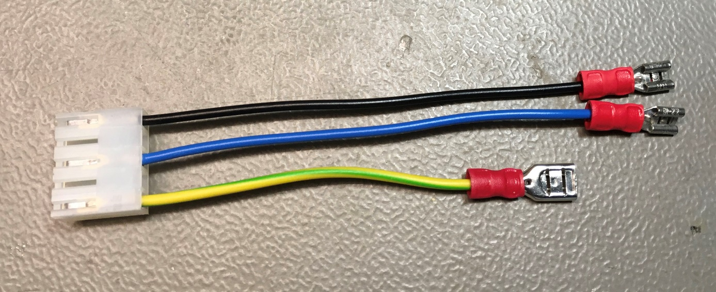

Figure 4: PCB Mains cable – W200

## The Mains Voltage Selector Cable – W300

This cable connects the switch for selecting the mains voltage to the PCB (J2). It is further referred to as “W300”. **W300 is optional** and only required for the 230V/115V version.

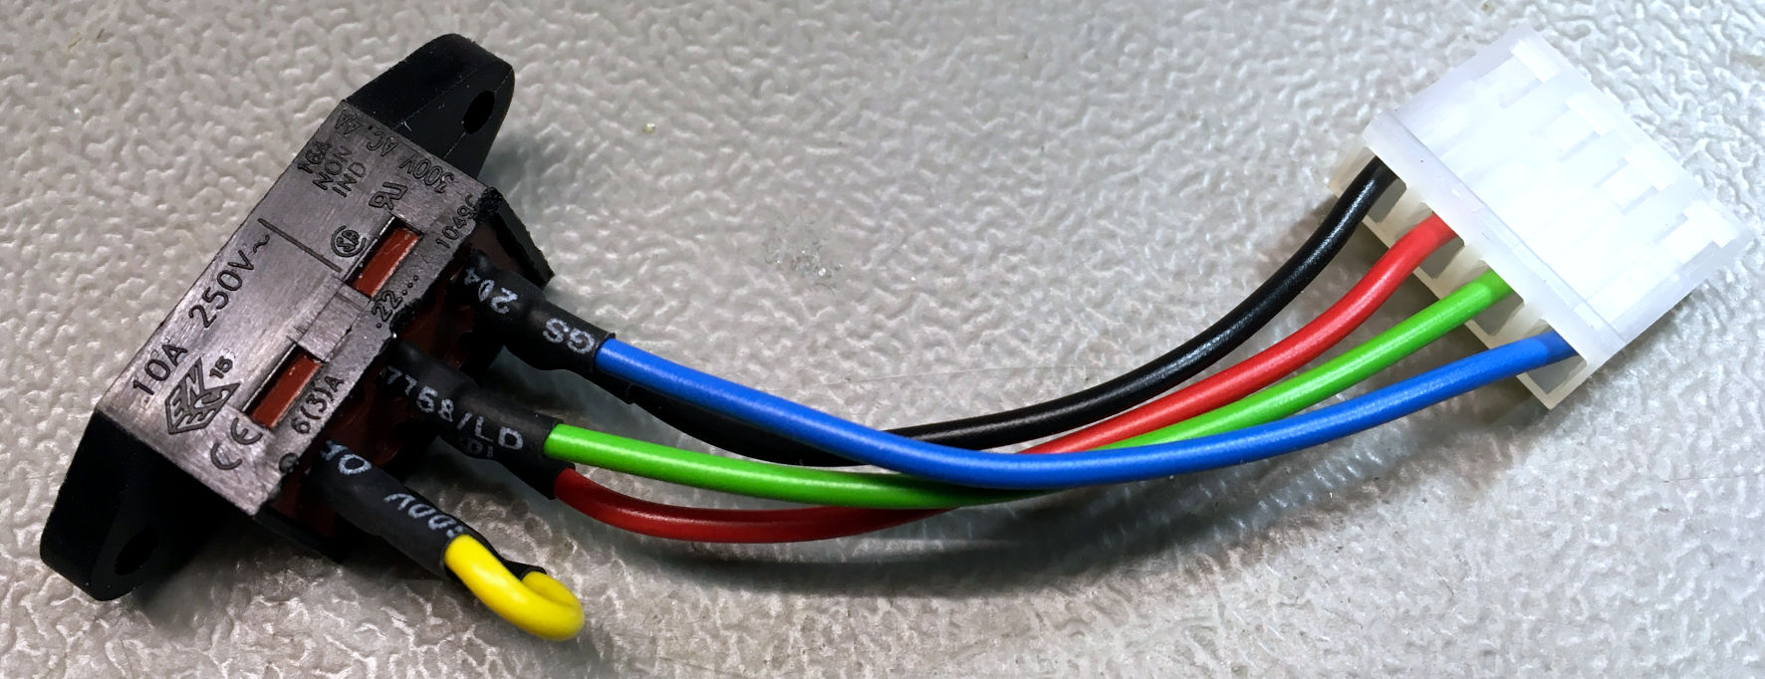

Figure 5: Voltage Selector Cable - W300

W300 has to be wired like shown in Figure 6. The wiring should be checked with a multimeter before the PSU Global is powered up. A failure can ruin the PSU.

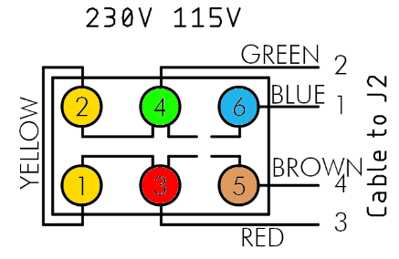

Figure 6: Wiring of the mains voltage selector switch

|  |  |  |
| --- | --- | --- |
| Position | Connected | Open |
| 230V | Pin 2 – 3 | Pin 4 – 3, Pin 1 – 2, Pin 1 – 4 |
| 115V | Pin 3 – 4, Pin 2 – 1 | Pin 2 – 3, Pin 1 – 4 |

Table 1: Mains Voltage Selector checks

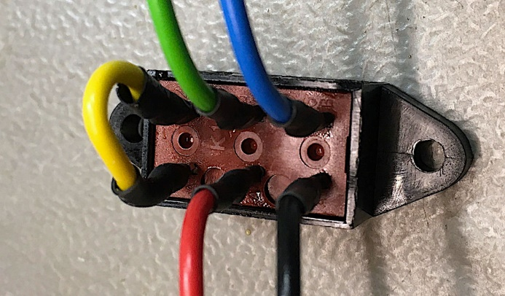

Figure 7: Mains voltage selector switch

Figure 7 shows the details of the mains voltage selector switch.

|  |  |  |  |  |
| --- | --- | --- | --- | --- |
| Pin (switch) | Signal | color | Length | Pin (J2, PCB) |
| 1 | Primary Coil Series | Yellow** | 4cm | - |
| 2 | Primary Coil Series | Yellow** | - | - |
| 3 | PR2A | red** | 8cm | 3 |
| 4 | PR1B | Green** | 8cm | 2 |
| 5 | Live | Brown* | 8cm | 4 (L) |
| 6 | Neutral | Blue* | 8cm | 1 (N) |

* Colors according to the local regulations (see above)

** Chose colors, so they do not interfere with the regulations mentioned before.

Material:

* Voltage selector switch: Bulgin T22205B436B
* Crimp housing: Molex 10321041
* 4 crimp terminals: Molex 08701031
* Shrinkable sleeve
* Cable, 5 colors

An alternative for the crimp terminals and the housing is

* Crimp housing: Adam Tech MTF-B-04 (tme.eu)
* Crimp terminal: Adam Tech MTF-B-C-01-R (tme.eu)

The Adam Tech terminals do not fit into the Molex housing and vice versa. The Adam Tech crimp housing fits on the Molex connector on the PCB.

I have also found replacements on AliExpress: <https://www.aliexpress.com/item/33023034171.html>

## Power Output Cable – W400

The installation of the PSU in a metal enclosure requires connection to PE of all metal parts of this enclosure. These connections need to be proved (at least with a multimeter) after finishing the assembly. One mounting hole of the PCB is connected to the PE of the installation. This is marked “← PE”. Chopper disks are recommended to attain a good connection.

In case, the power cables should stay connected to this PSU, strain reliefs are required. An alternative way is a DIN-jack on the back panel of the power supply and extra cables to have as few cables in the installation as possible.

|  |  |  |  |
| --- | --- | --- | --- |
| C64 Power Jack | Pin | Voltage | J3 |
|  | 1 | - | - |
| 2 | GND | 2 |
| 3 | - | - |
| 4 | - | - |
| 5 | +5V | 1 |
| 6 | 9VAC(1) | 3 |
| 7 | 9VAC(2) | 4 |

Table 2: Power jack of the C64

Table 2 shows the power jack of the C64. The view is on the particular contact side. This is identical with the view on the solder side of the respective DIN plugs. The cables soldered to the din plugs should be 0.5mm²/AWG21 (LiYY 4x0.5mm²). It is possible to use 0.75mm²/AWG20 wires, but this might require to clip off some of the wire strands, since the solder cups of the DIN plugs are usually not capable of accepting a wire of this diameter. The outer diameter of the power cable has to be 5.5mm.

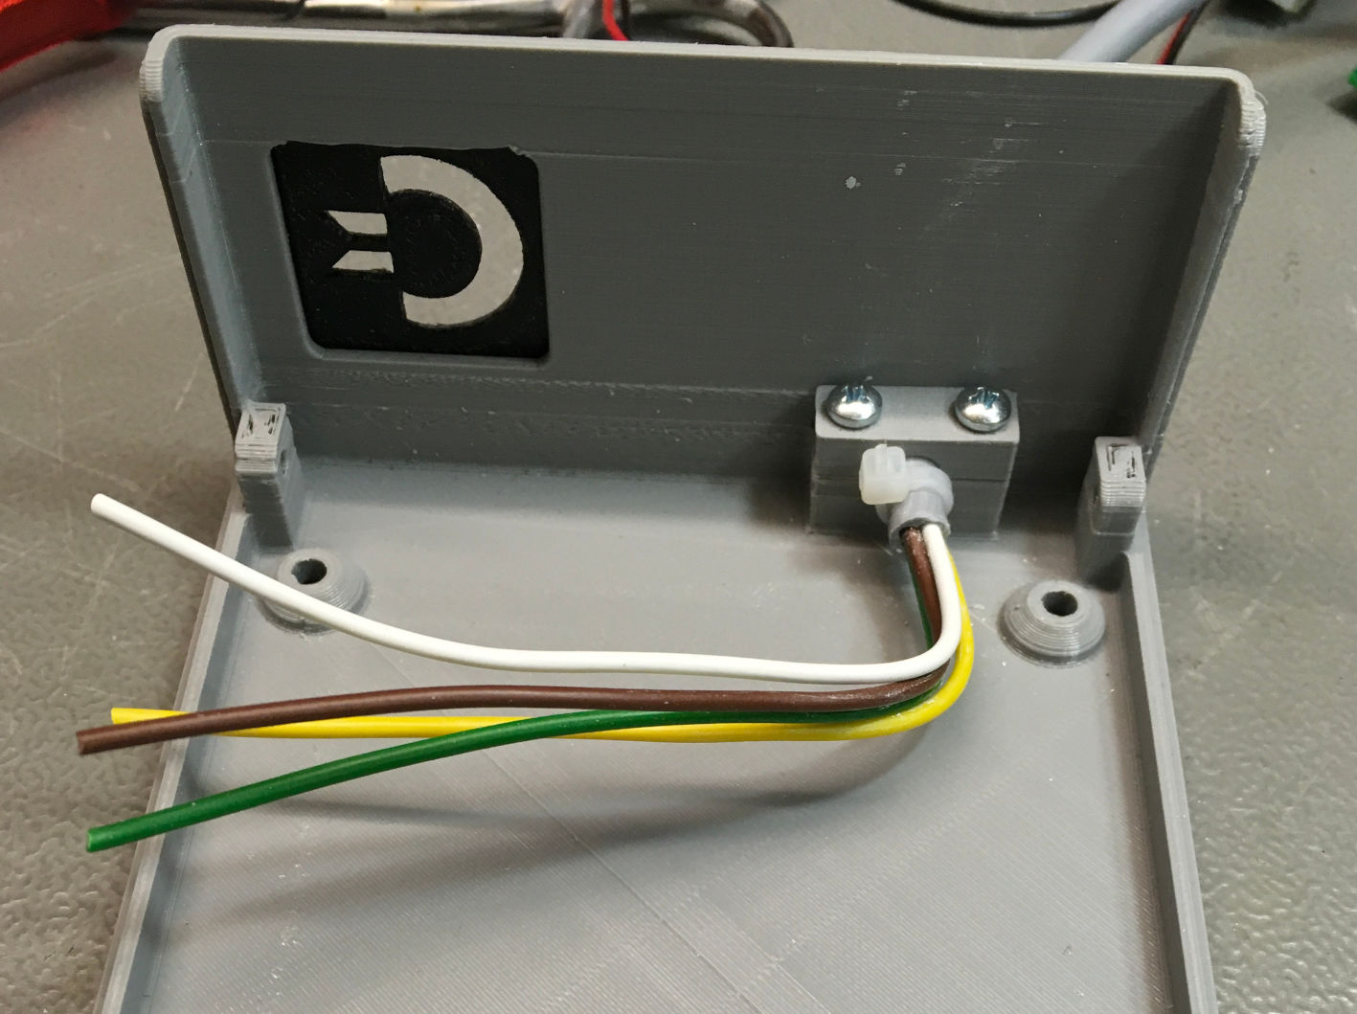

Figure 8: Installing the power cable

Figure 8 shows the end of the power cable, that ends inside the case. The outer insulation was stripped off about 10cm. The cable is secured with the strain relief and an additional cable tie. It is possible to crimp the cable outside the case and insert the cables with the crimp connector one by one, but the recommended way is to install the cable in the case and then crimp it.

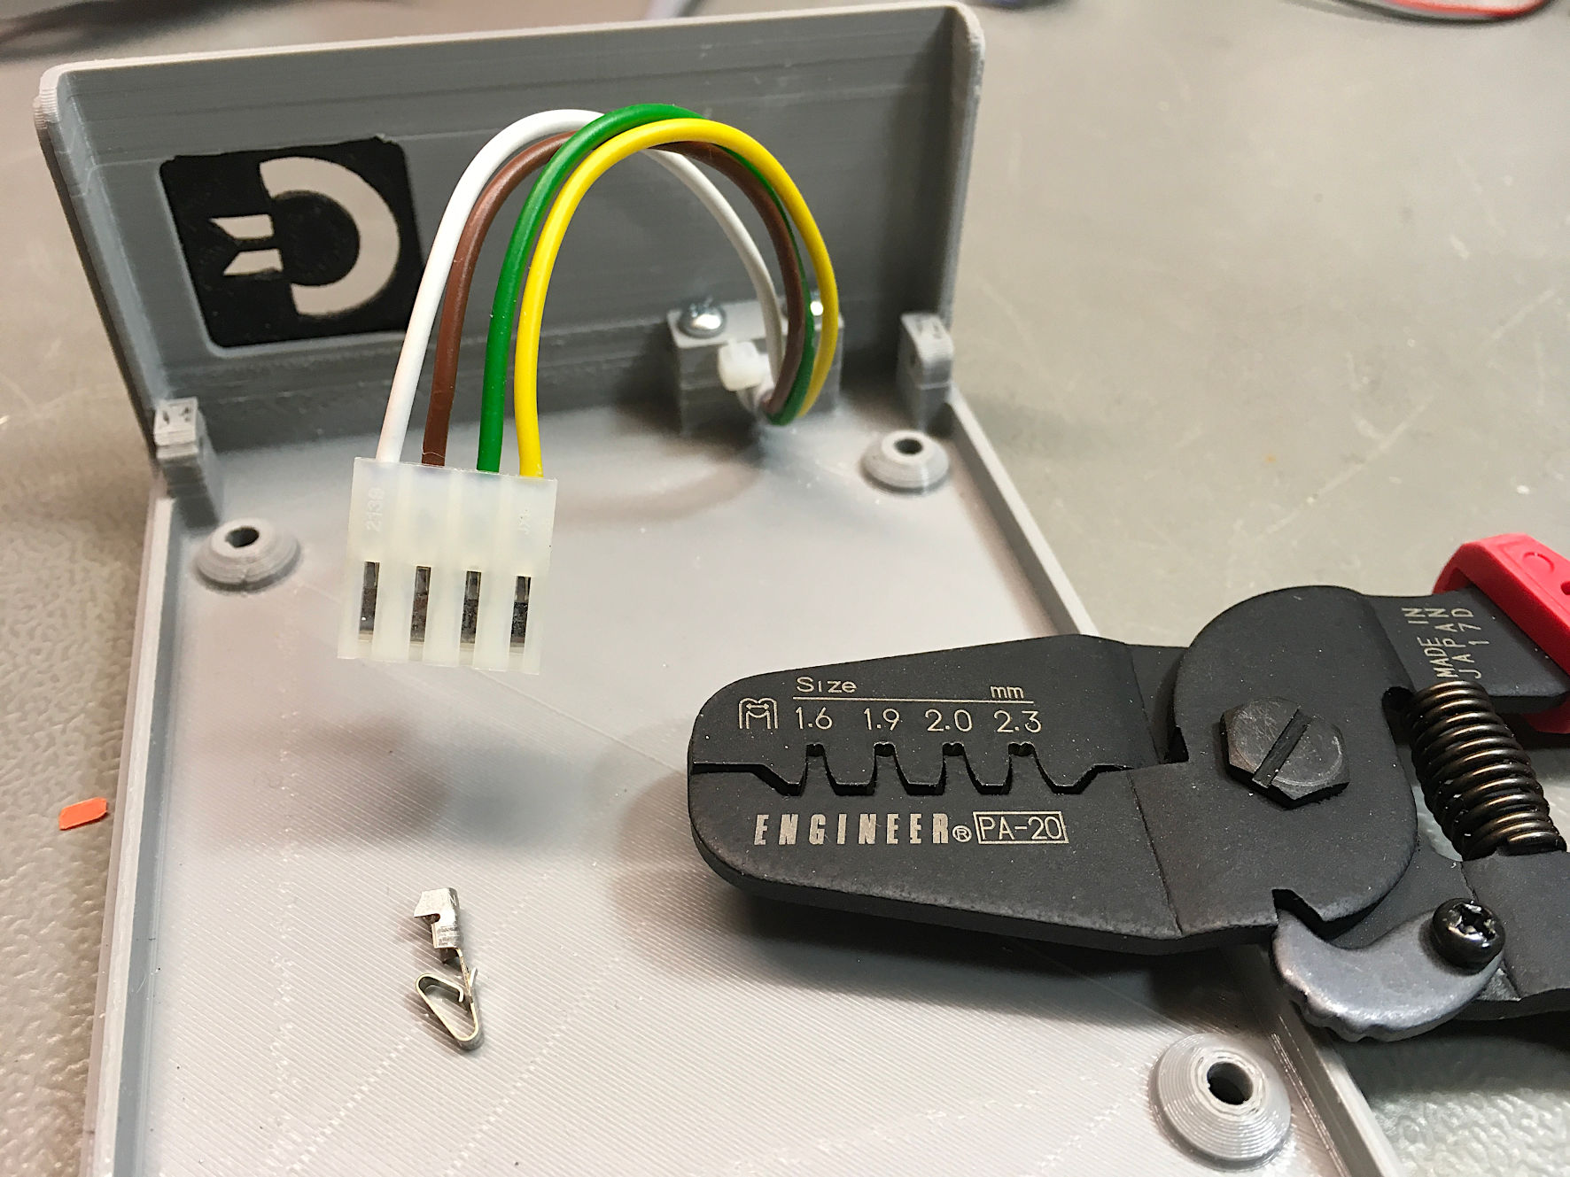

Figure 9: The power cable with crimp housing installed

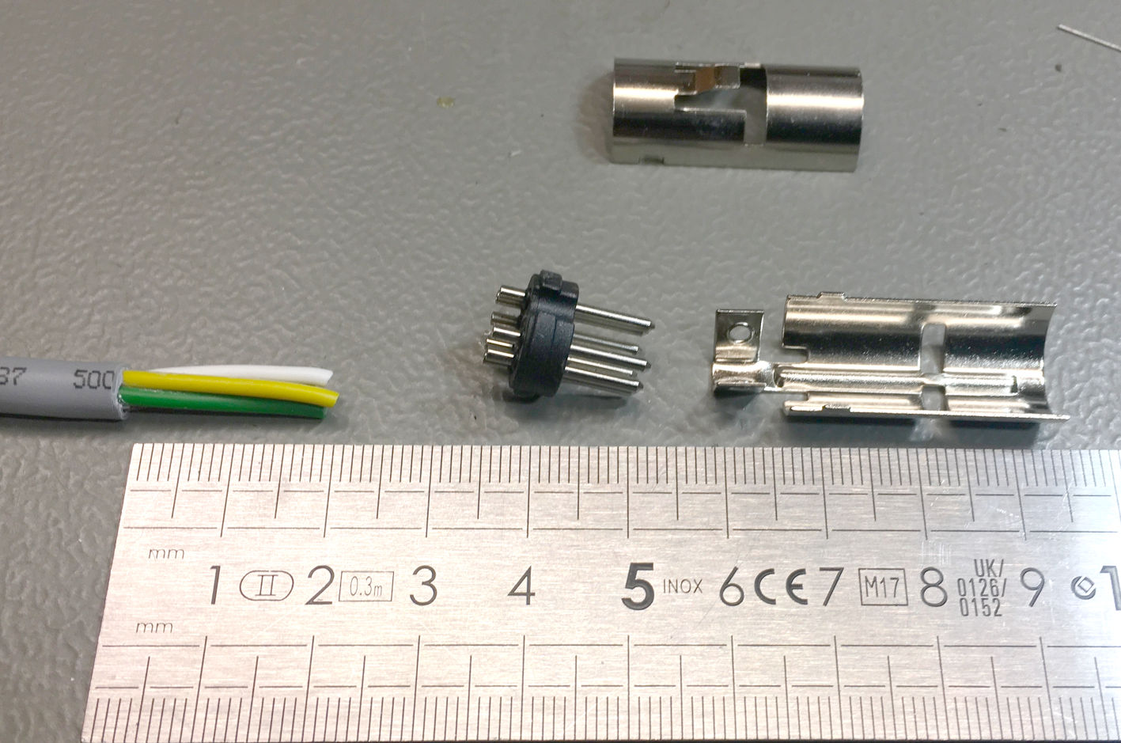

Figure 10: The output (DIN) connector

For soldering the DIN connector, the outer insulation should be stripped off about 12mm. The wire insulation should be stripped off about 2mm. Before soldering, the wire strands should **not** be tinned, otherwise it will not be possible to insert them into the solder cups. A drop of (liquid) flux is helpful for soldering. It should be taken into account, that the body of the connector might melt and the pins get out of alignment. I have heard about the “potato method” for soldering DIN connectors: The connector is pressed into a raw potato. The wires can then be soldered, while the pins stay in alignment.

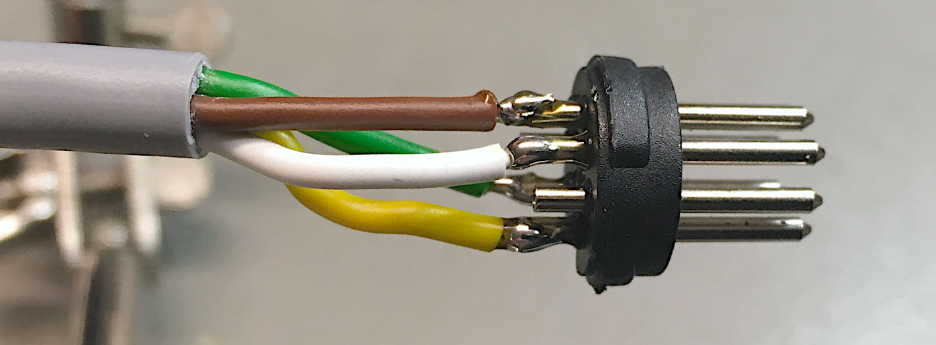

Figure 11: The soldered DIN connector

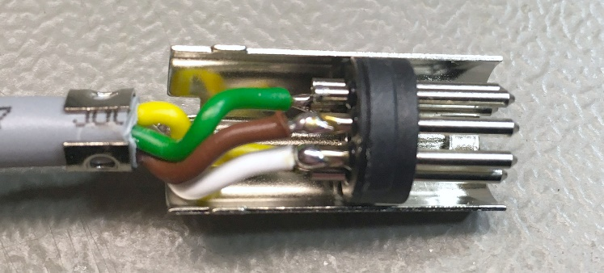

Figure 12: Installing the shielding of the DIN connector

## The Logo Cable – W500

The logo can be connected as a power indicator lamp. It connects to a “C64 standard” three-way DuPont connector. The GND wire connects to the middle pin, the plus wire connects to one of the outer pins (either 1 or 3, both is fine).

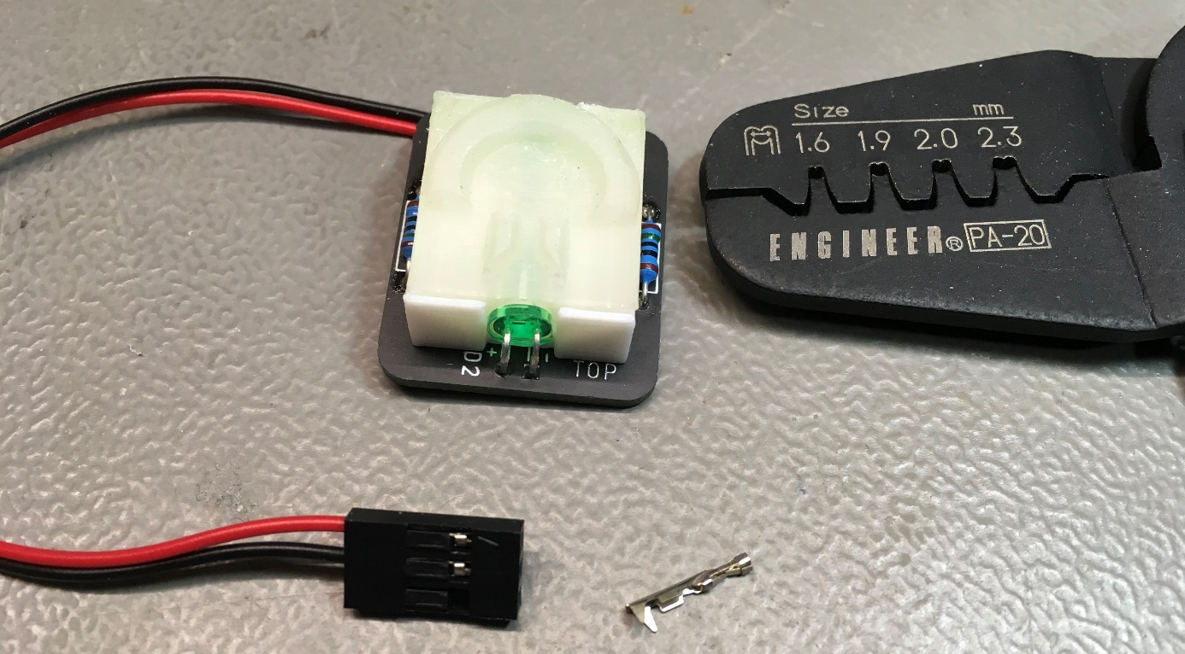

Figure 13: The logo cable - W500

A simple power LED can be connected (in case the PSU is installed in another case). The resistor R1 on the PCB has to be selected accordingly:

* Logo: 0Ω
* Red, green or yellow LED: 330R
* Blue LED: 47Ω - 51Ω

# Case material

## Required screws

|  |  |  |
| --- | --- | --- |
| Qty | Material | Purpose |
| 4 | M3x10 (DIN7985) | PCB |
| 4 | Nut M3 (DIN 985=self-locking) | PCB |
| 2 | C2.9x9.5 (DIN 7981) | Strain Relief |
| 2 | M3x12, counter sunk (DIN 965) | Appliance connector |
| 2 | Nut M3 (DIN 985=self-locking) | Appliance connector |
| 2 | M3x12, counter sunk (DIN 965) | Optional: Voltage selector switch |
| 2 | Nut M3 (DIN 985=self-locking) | Optional: Voltage selector switch |
| 4 | C2.9x6.5, counter sunk (DIN 7982) | Top shell/bottom shell |

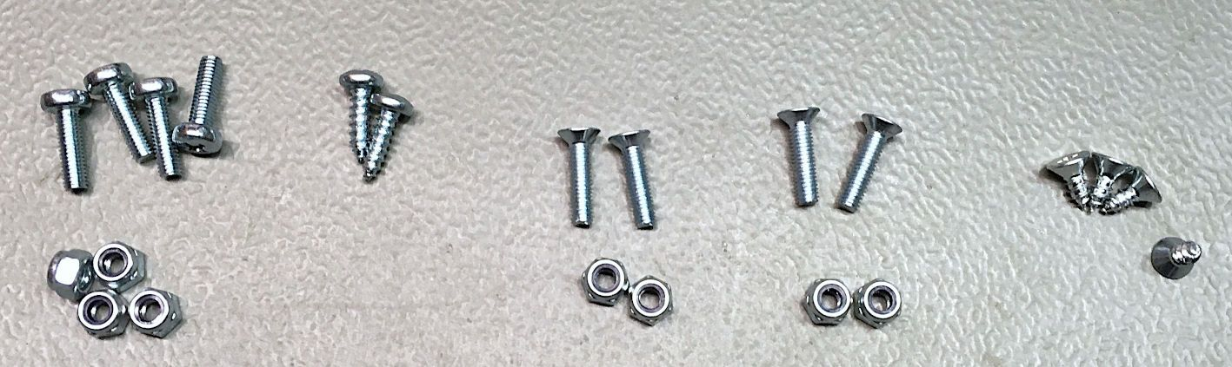

Figure 14: Required mounting screws

## 3D Prints

There are two versions of bottom shells and one version of the top shell:

* 230V only bottom shell without a cutout for the voltage selector switch
* 230V/115V with a cutout for the mains voltage selector

The top shell is identical.

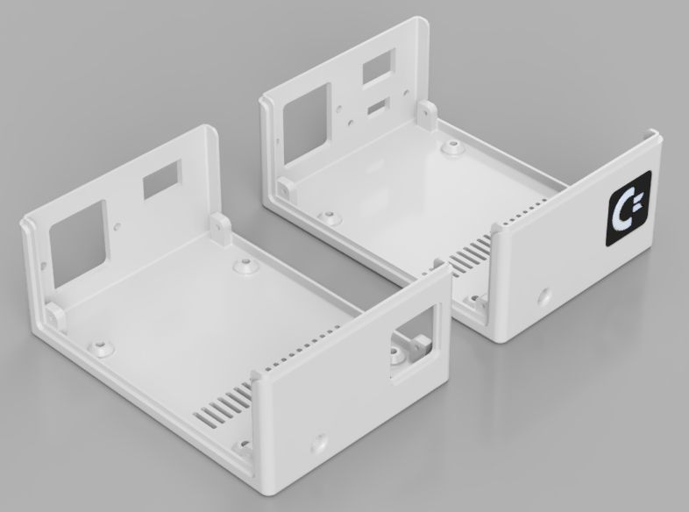

Figure 15: Bottom shells: 230V only (left), 230V/115V (right)

The temperatures can reach 45°C – 50°C inside the case (above the transformer), so it might be a good idea to used something more heat resistant like PETG or ABS for printing the case shells.

Further, there is an illuminated logo. This can be printed with PLA.

You have two options:

* Commodore logo (<https://github.com/svenpetersen1965/Illuminated-Commmodore-logo>)
* 64 logo (<https://github.com/svenpetersen1965/Illuminated-64-logo>)

Both logos might be copy right protected.

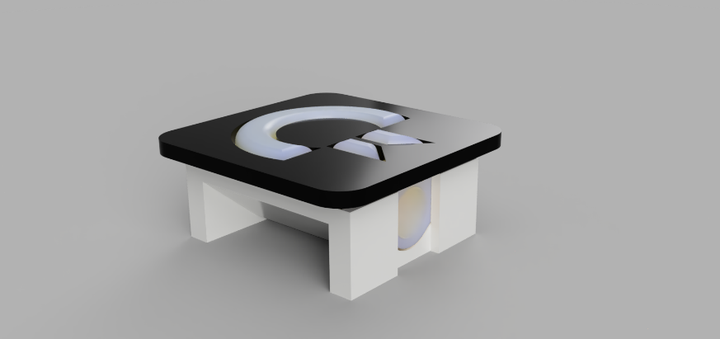

Figure 16: Commodore logo (without PCB)

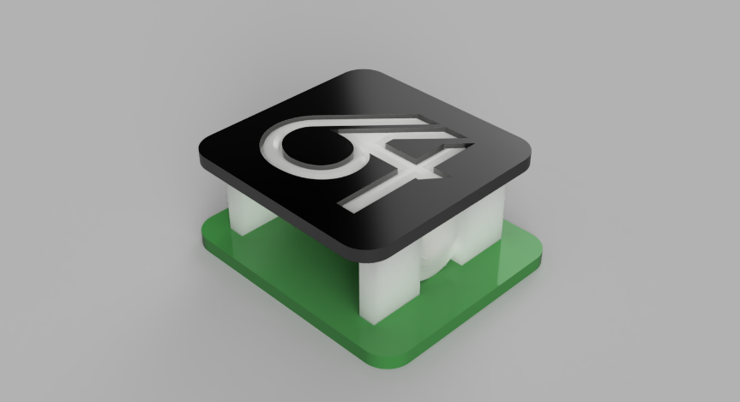

Figure 17: 64-logo (with PCB)

The illuminated body should be printed with clear filament (PLA) 100% infill. The reflector requires some white filament, the face plate should be printed with a dark filament (e.g. black PLA). The PCB is helpful, but also a perf board, which holds the two LEDs and two current limiting resistors is possible. Diffused LEDs are a better choice than clear LEDs, go for the bright ones.

It is not required to have a 3D printed case. Alternatively, a suitable metal case can be used. In this case, you need a strain relief for the output cable.

# Assembly inside the 3D printed case

## STEP 1

The first step should be gluing in the logo face plate into the bottom shell. A special plastic glue is required, here. The type that dissolves the plastic a bit is recommended, because that is producing an excellent bond. This should dry for some time, so the face plate will stay in place while mounting.

## STEP 2

The next step is optional, since the mains voltage selector switch (W300) is only required for the 230V/115V version.

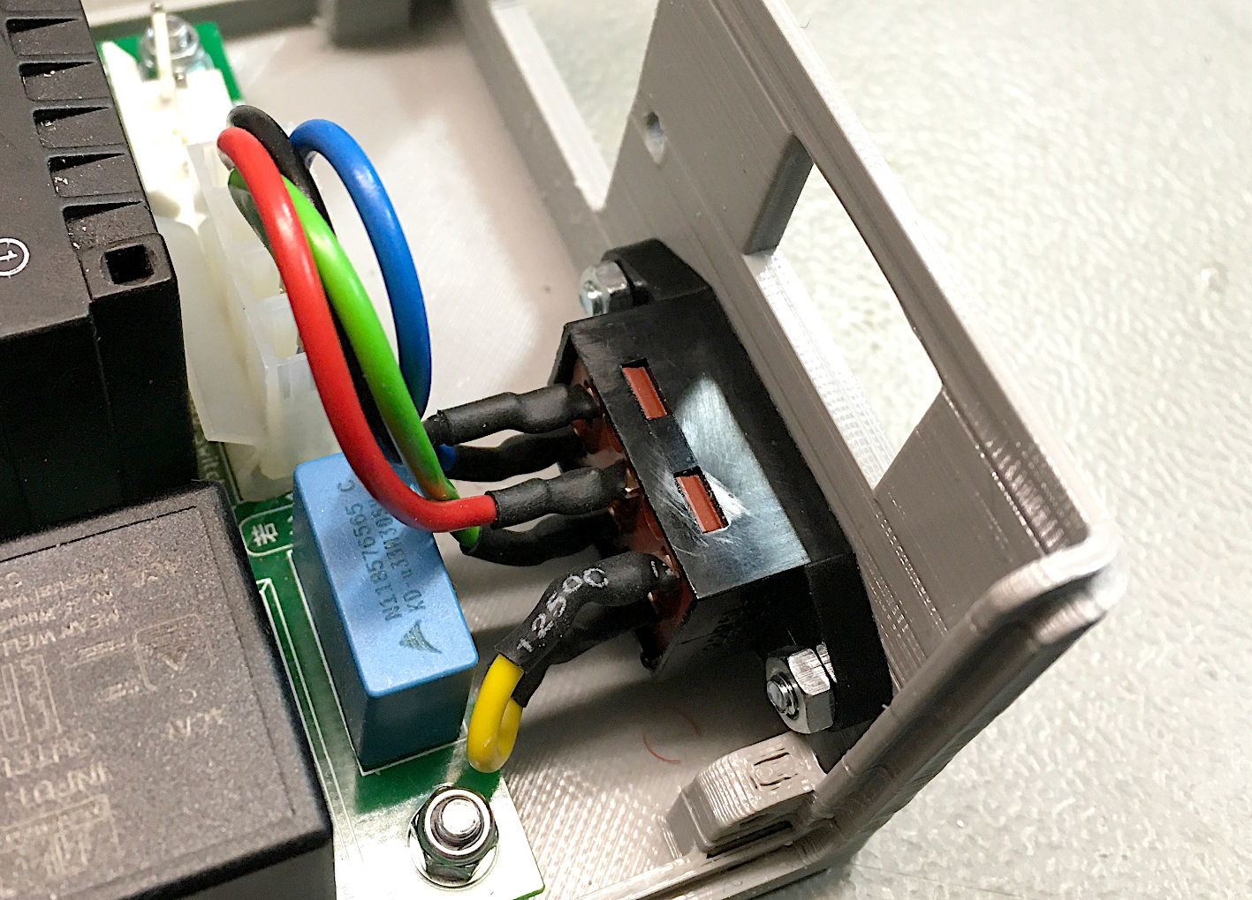

Figure 18: Mains voltage selector installed

This requires two M3x12 counter sunk screws and two nuts. Self-locking nuts are recommended (Figure 18 shows “ordinary” nuts). It is easiest to start without the PBC mounted.

## STEP 3

Mount the PCB with four M3x10 screws and 4 M3 self-locking nuts. The side with J1 and J2 is oriented towards the cutout for the power switch and the appliance connector. The already installed power output cable (W400) and the optional W300 voltage selector can be connected to the PCB.

## STEP 4

The mains cable (W200) should be connected to the PCB. Before screwing the appliance connector/mains cable (W100) to the case, the green/yellow PE cable should be connected to the appliance connector (Figure 19). The latter is then mounted with two M3x12 countersunk screws and M3 nuts.

The cutout dimensions are:

27.7mm x 31.7, screw distance: 36mm.

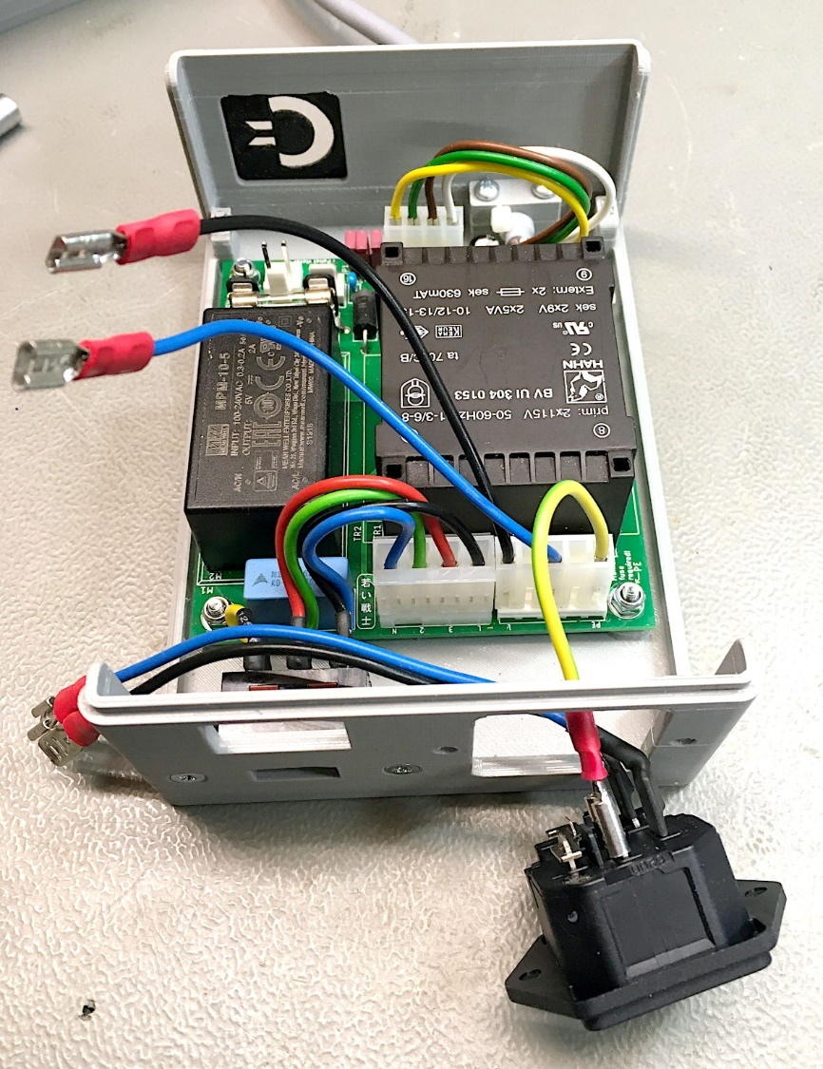

Figure 19: Installing the mains cable W100

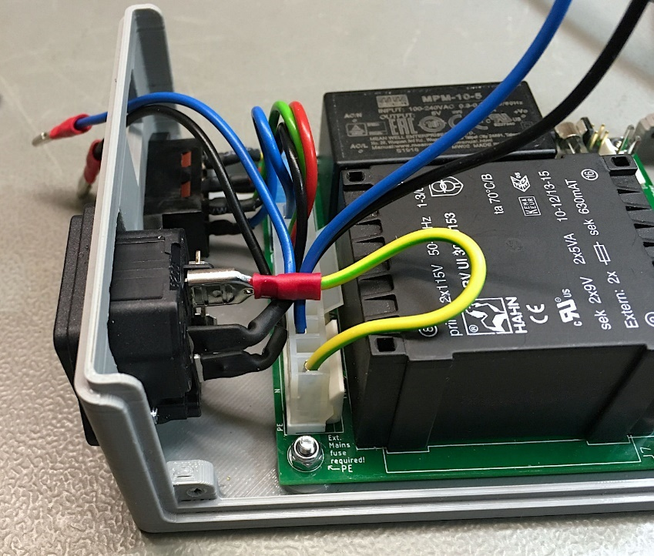

Figure 20: Mains cable W100 installed

## STEP 5

This is installing the power switch. It can either be an illuminated version or a non-illuminated version. The tests at 115V have shown, that an illuminated (230V) switch is pretty dim then. Here, a normal power switch, that fits the cutout (19.8mm x 13mm) might be the better choice.

The illuminated switch has to be wired, that the lamp is connected to the output side of the switch.

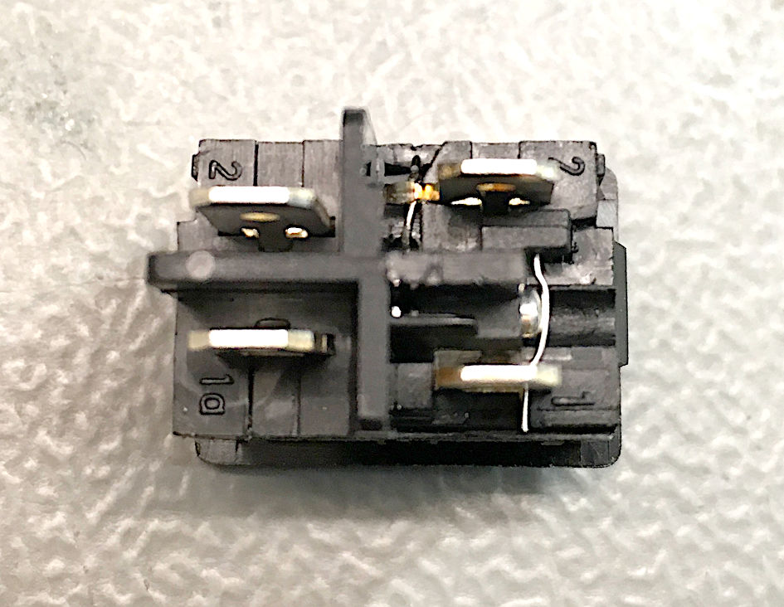

Figure 21: Illuminated mains switch

Figure 21 shows the mains switch. Here, the input side is at the left, the output side with the lamp connected is at the right.

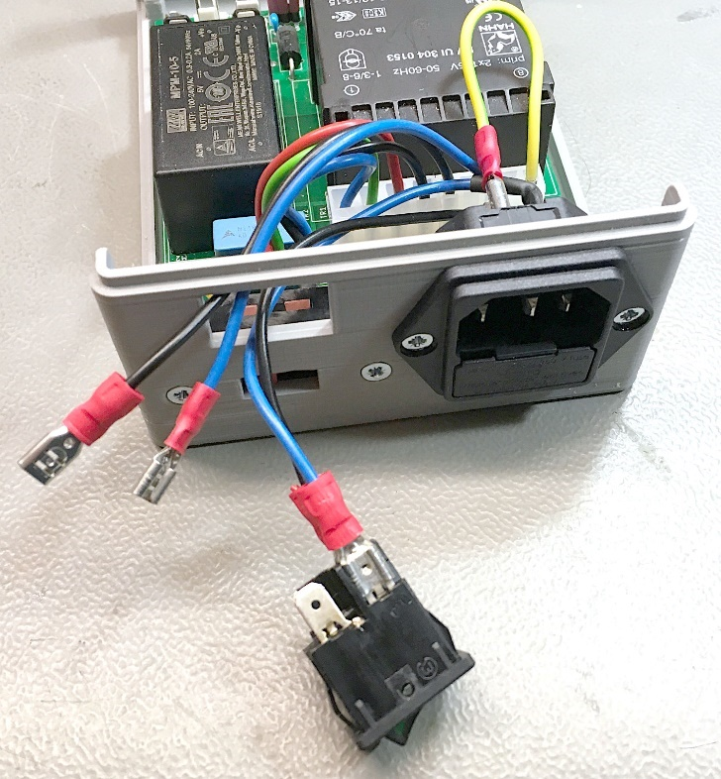

Figure 22: Installing the mains switch

The mains input from W100 connects to the input side of the switch (Figure 22).

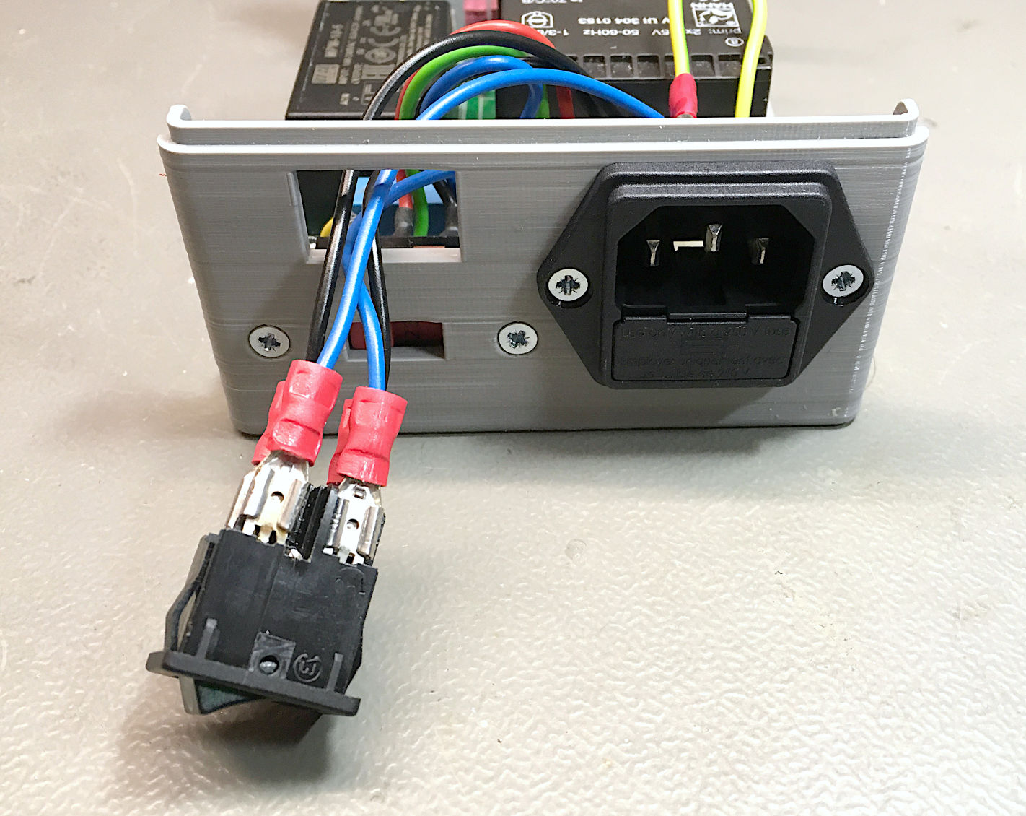

Figure 23: Mains switch wired

The mains cables from the PCB (W200) connect to the output side of the power switch. Blue (N) should be adjacent to blue and black (L) to black (Figure 23). Finally, the switch can be pressed into the cutout. It should snap in place and stay firmly (Figure 24).

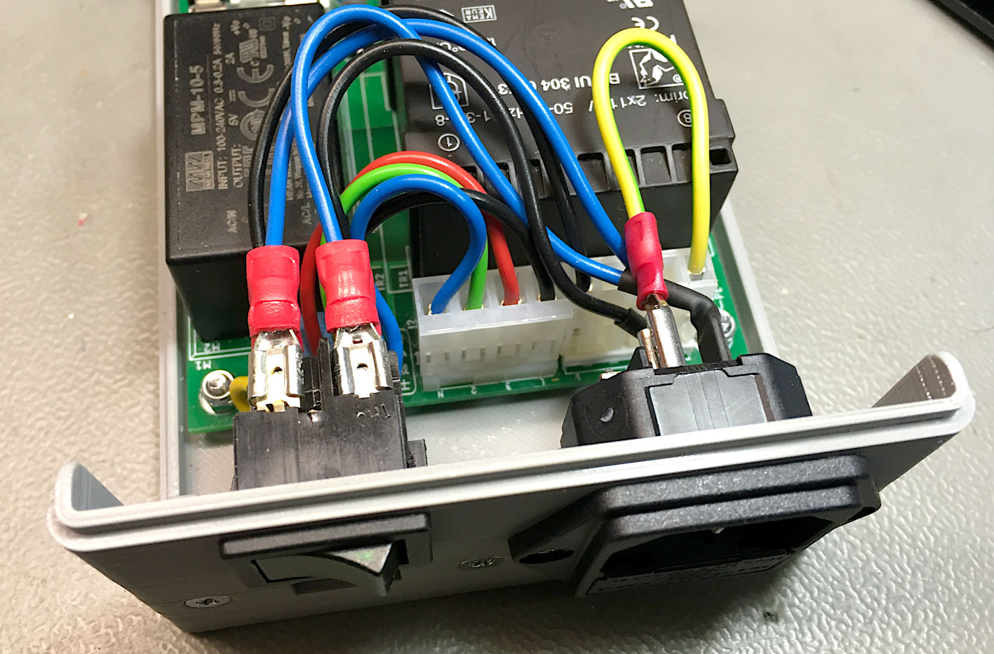

Figure 24: Mains switch installed

## STEP 6

Finally, the logo has to be glued in place. Again, the same plastic glue like in STEP 1 is recommended. The logo should be clamped to the case for a while to let the glue dry. The logo cable W500 is then connected to the LED connector J6 (Figure 25).

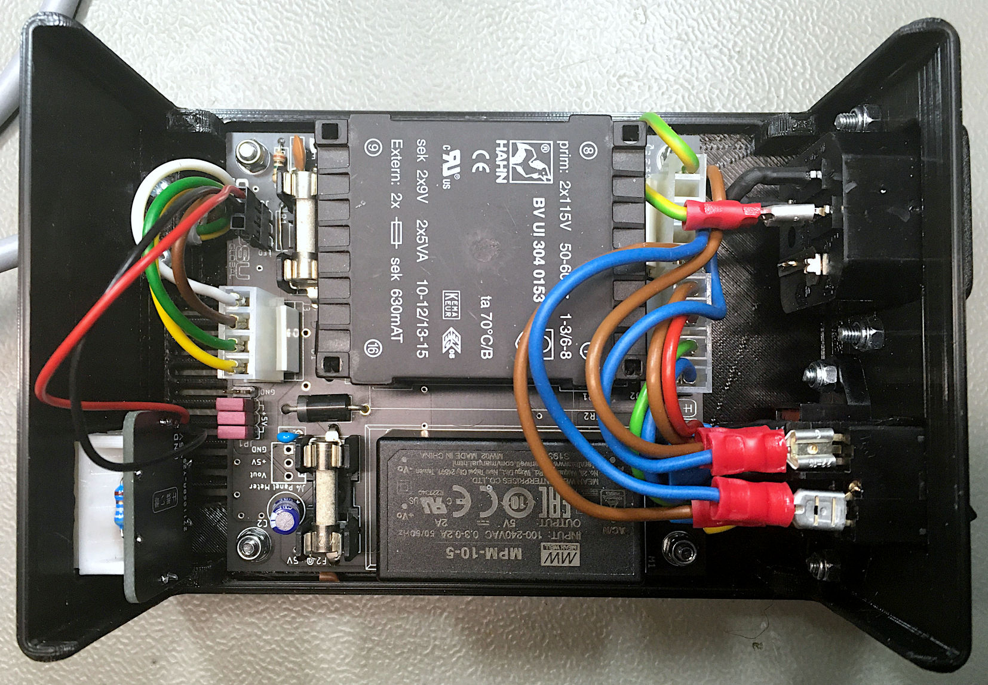

Figure 25: PCB Rev. 1 completely wired

Now, the top shell is slid over the bottom shell. The desired orientation is marked inside. “FRONT” should point to the output cable side. It is screwed in place with the four C2.9x6.5 countersunk screws.

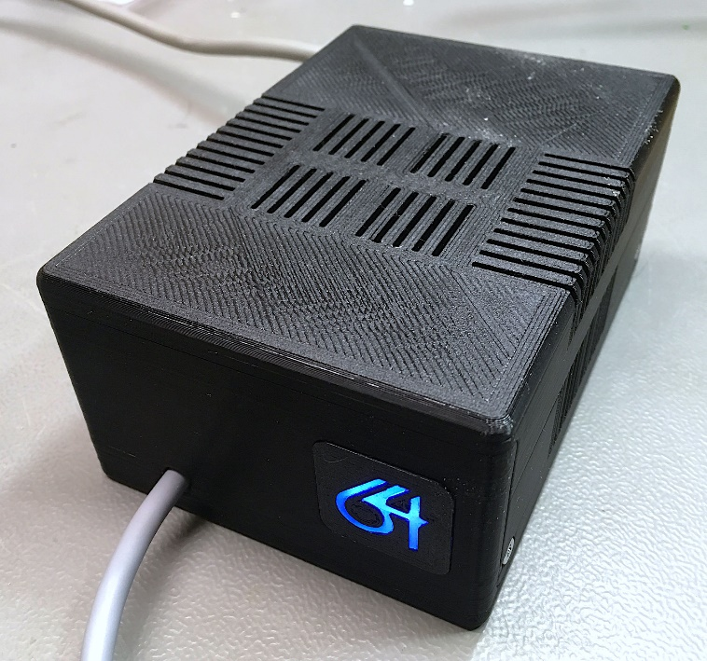

Figure 26: Completed Power Supply Global

# Testing

After finishing the wiring, it is required to test the complete device. Swapping the voltages by confusing the pins or the wiring will usually damage the connected devices. The +5V should measure between +4.9V and +5.2V. The 9VAC are not regulated and is quite a bit higher without load. 12VAC is still an acceptable reading. For the pinning, refer to Table 2: Power jack of the C64. Remark: When looking at the pin side of the connector, the pinning is mirrored.

# Revision History

## Rev. 0 → Rev. 1

Since the tests have shown, that a panel meter is very inaccurate measuring the current, the current measurement path has been dropped. Only panel volt-meters can be connected. For the sake of a minimum voltage drop, the current-carrying copper-traces with a 5V level are as wide as possible. The pin-header, that can connect to an optional voltage supervisor (“saver”) has been changed from 6 pins to 8 pins (three pairs of 5V pins instead of two). The reason is also minimizing the voltage drop over this connector.